Maze Problem
Consider the maze shown in the figure below. S is the initial state and G is the goal state. Dark squares are blocked cells. All squares, except for the start and goal states, are labelled, with row and column numbers. For example, n54 is the cell in the fifth row, fourth column.
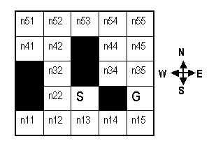
For all the questions in this problem:
- the graph states are the squares of the maze.
- there are links along the cardinal compass directions to neighboring squares (that are not blocked). That is, diagonal moves are not permitted, nor are moves into or across a black square.
- the successors of a state are to be generated in a FIXED order to be drawn from left to right, namely N, E, S, W.

We say that a state is expanded when a path to that state is pulled off of Q.
For Breadth-First search (with a Visited List), indicate the order in which states are expanded. Enter a sequence of state names starting with S and ending with G, e.g. S n13 n22 ... G.

